Annual Report
2012–2013

Citation: ECART. 2018. Ethics Committee on Assisted Reproductive Technology
Annual Report 2012–2013. Wellington: Ethics Committee on Assisted Reproductive Technology.
Published in July 2018 by the Ethics Committee on Assisted Reproductive Technology
PO Box 5013, Wellington, New Zealand
ISBN: 978-1-98-853955-3 (online)
HP 6807
This document is available on the ECART website: www.ecart.health.govt.nz

Contents
About ECART 1
Purpose of this report 1
Chairperson’s report 2
Applications 2
Additional function 2
Committee members 2
Membership and attendance 3
Membership 3
Attendance 5
Applications reviewed 6
Creation and use, for reproductive purposes, of an embryo created from donated eggs in conjunction with donated sperm 7
Surrogacy arrangements involving providers of fertility services 8
Donation of eggs or sperm between certain family members 9
Embryo donation for reproductive purposes 10
Issues and complaints 11
Advice on established procedures 11
Issues referred to ACART 11
Complaints received 11
Appendix A: Applications reviewed by ECART in 2012/13 12
Appendix B: Applications reviewed by ECART before 1 July 2012 but ongoing throughout 2012/13 15

List of Figures
Figure 1: The number and type of applications reviewed by ECART by year, 2005/06–2012/13 6
Figure 2: Birth outcomes from current applications for creating and using, for reproductive purposes, an embryo created from donated eggs in conjunction with donated sperm by year, 2010/11–2012/13 7
Figure 3: Birth outcomes of current applications for surrogacy arrangements involving providers of fertility services by year, 2005/06–2012/13 8
Figure 4: Birth outcomes from current applications for the donation of eggs or sperm between certain family members by year, 2005/06–2012/13 9
Figure 5: Birth outcomes for current applications from embryo donation, by year, 2005/06–2012/13 10

About ECART
The Ethics Committee on Assisted Reproductive Technology (ECART) is the ethics committee for the purposes of the Human Assisted Reproductive Technology Act 2004 (the HART Act), which aims to secure the benefits of these technologies by promoting and protecting the health, safety, dignity and rights of those involved in them.

Under the HART Act, ECART’s prior approval is required in order to conduct:
- human reproductive research (that is, research that involves the creation or use of human gametes, human embryos or hybrid embryos)
- assisted reproductive procedures, except those that have been declared to be ‘established procedures’.

ECART’s main role is to review applications from fertility clinics that wish to conduct ‘assisted reproductive procedures’ on individuals, or ‘human reproductive research’, against guidelines issued by the Advisory Committee on Assisted Reproductive Technology (ACART).

Purpose of this report
ECART’s Terms of Reference require it to report annually to the Minister of Health.

This report must include information on the membership of the committee, a summary of the applications reviewed during the year, details of any complaints received (and how they were resolved) and areas of review that caused difficulty in making decisions. The report should also detail the number and type of applications for assisted reproductive procedures and human reproductive research, the date of first review, the final outcome and the reason for deferring or declining any applications.

Chairperson’s report
I am pleased to present the eighth Annual Report of ECART, for the year ending 30 June 2013.

Applications
In 2012/13, ECART reviewed 55 applications over five meetings; compared with the 2011/12 year when it reviewed 47 applications over five meetings. ECART expects the number of applications to grow, in view of recent amendments to the HART Act’s provisions on storing gametes and embryos. ACART has issued guidelines to ECART so that ECART can consider individual applications for extending the storage period. ECART recognises the need for its review process for extended storage applications to be as focused and efficient as possible and has implemented a streamlined application form to ensure this.

Additional function
Following a request from fertility clinics to be able to approach ECART for informal advice on established procedures, ECART wrote to the Minister of Health (the Minister) asking for this function to be assigned pursuant to section 28(1)(e) of the HART Act. The Minister agreed to assign this function to ECART and asked for details of such advice to be included in future Annual Reports. No such request was received in 2012/13.

Committee members
I wish to record my gratitude and thanks to the committee member who retired in 2012/13. Associate Professor Huia Tomlins-Jahnke worked hard for ECART and made an enormous contribution to its workload. Her ability to bring Māori perspectives to the committee’s deliberations and her knowledge of Māori views on assisted reproductive technology was particularly highly valued by her fellow committee members and the wider fertility community.

I am also very grateful to all ECART members for their continuing commitment, without which the committee could not function effectively. I look forward to another interesting and fulfilling year in 2013/14.

Kate Davenport QC
Chairperson

Membership and attendance

Membership
Note: Dr Adriana Gunder was reappointed to ECART for a second term during 2012/13.

Lay members
Ms Kate Davenport QC (Chairperson)
Membership category: expertise in the law
Date of first appointment: 7 August 2008
Current term expires: 21 July 2014
Ms Kate Davenport QC is a barrister sole practising in the area of civil and commercial litigation in Auckland. Kate has an LLB Honours, Master of Jurisprudence with Distinction and a post-graduate certificate in Health Science (Ethics). Kate has a particular interest in health law. Kate was the Deputy Chair of the New Zealand Health Practitioners Disciplinary Tribunal, a tribunal that disciplines all registered health practitioners in New Zealand. Kate has also been the Director of Proceedings for the Health and Disability Commissioner.
Dr Brian Joseph Fergus
Membership category: consumer perspective
Date of first appointment: 1 April 2012
Current term expires: 1 April 2015
BSc, MSc (1st class Honours) Auckland, PhD, McGill University, Montreal, Canada
Dr Brian Fergus has previous private-sector experience at management level and senior management consulting experience. He was also elected Board member of Auckland District Health Board, where he chaired the Community Health subcommittee and was a member of the Audit Committee. Currently, he is Chair of Northern A Health and Disability Ethics Committee. Dr Fergus has four children and seven grandchildren.
Dr Adriana Gunder QSM JP
Membership category: disability perspective
Date of first appointment: 1 April 2010
Current term expires: 1 April 2016
Dr Adriana Gunder is a disability representative and a member of both the New Zealand Health Practitioners Disciplinary Tribunal and the National Ethics Advisory Committee (NEAC). Dr Gunder completed her doctoral degree in Biological Sciences and a post-doctoral degree in Biophysics at the University of Pavia, Italy. She is the Chairperson of the Local Council of Auckland Central, East and South of the New Zealand Red Cross. She has been an elected member of the Auckland City Council: Eastern Bays Community Board (2006–2010) and a volunteer of Victim Support (1995–2007).
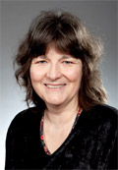 | Dr Carolyn Mason  Membership category: expertise in ethics  Date of first appointment: 21 July 2011  Current term expires: 21 July 2014  Dr Carolyn Mason is currently a lecturer in Ethics at the University of Canterbury  (2001–present). Before this, she was a lecturer at Lincoln University (2000) and a science research technician (1979–1985). Dr Mason completed a Bachelor of Science in Psychology and Philosophy (1992), a Master of Arts in Philosophy (1999) and a Doctor of Philosophy in Philosophy at the University of Canterbury (2013). She was a member and Chair of the Upper South A Regional Ethics Committee (2005–2008), and a member and Deputy Chair of the Canterbury Regional Health and Disability Ethics Committee (2002–2004). She is currently a member of the University of Canterbury Human Ethics Committee.
Associate Professor Huia Tomlins-Jahnke
Membership category: expertise in ethics
Date of first appointment: 19 October 2006
Current term expired: 1 April 2013*
Associate Professor Huia Tomlins-Jahnke (Ngāti Kahungunu, Ngāi Tahu, Ngāti Toa Rangatira and Ngāti Hine) is currently a Māori Education lecturer at Massey University, where she has worked for 12 years. She has extensive expertise and experience in Māori theoretical, methodological and ethical frameworks and working with Māori communities. Her PhD investigated the nature of tribal service provision in health and social services. She is a current member of the Social & Human Sciences Sub Commission of the New Zealand National Commission for UNESCO and the Sub Commission’s Pacific Ethics Consultation Steering Committee.

Non-lay members
Dr Freddie Graham
Membership category: expertise in human reproductive research
Date of first appointment: 21 July 2011
Current term expires: 21 July 2014
Dr Freddie Graham is currently an obstetrician and gynaecologist at Fertility Associates. He established Fertility Associates as New Zealand’s first private fertility clinic in 1987 and was awarded the Companion of the New Zealand Order of Merit for his services to medicine in 2009. Dr Graham has completed a Bachelor of Medicine and Bachelor of Surgery at the University of London and has been made a Fellow of The Royal College of Surgeons of Edinburgh, as well as a Fellow of The Royal Australian and New Zealand College of Obstetricians and Gynaecologists.
Dr Deborah Payne
Membership category: expertise in assisted reproductive procedures
Date of first appointment: 1 April 2012
Current term expires: 1 April 2014
Dr Deborah Payne is a senior lecturer and co-director of the Centre for Midwifery and Women’s Health Research at Auckland University of Technology (AUT). She completed her PhD at Massey University in 2003. Dr Payne has a longstanding interest in women’s health. Recent research projects have explored issues in relation to women and disability (eg, motherhood and disability) and assisted reproductive technologies (eg, perceptions of short-cycle IVF, nurses caring for clients undergoing ART and embryo donation). Dr Payne is a member of the Auckland Women’s Health Council.
Dr Deborah Rowe
Membership category: expertise in assisted reproductive procedures
Date of first appointment: 28 June 2007
Current term expires: 21 July 2014
Dr Deborah Rowe (Ngāi Tahu) is currently a nurse consultant for the Auckland District Health Board (Auckland DHB), a lecturer at The University of Auckland and a senior staff nurse at the Women’s Health Neonatal Intensive Care Unit (NICU). She is a member of the Nursing Council of New Zealand, the Māori Advisory Committee National Screening Unit, the Newborn Screening Advisory Committee, the Auckland DHB Māori Nurses Group, as well as a part-time community support worker for the Intellectually Handicapped of New Zealand (IHC).
* ECART’s Terms of Reference provide that unless a person vacates their office sooner, every appointed member of ECART shall continue in office until their successor is appointed.

Attendance
ECART held five meetings in the year 1 July 2012 to 30 June 2013.

 |  | Meeting dates
 |  | 19/7/12 | 27/9/12 | 29/11/12 | 7/3/13 | 30/05/13 | Total
Members | Ms Kate Davenport (Chair, L) |  |  |  |  |  | 5/5
 | Dr Brian Fergus (C) |  |  |  |  |  | 5/5
 | Dr Adriana Gunder (D) |  |  |  |  |  | 5/5
 | Dr Carolyn Mason (E) |  |  | A |  |  | 4/5
 | Ass Prof Huia Tomlins-Jahnke (E) |  |  |  |  |  | 5/5
 | Dr Freddie Graham (HRR) | A |  |  |  |  | 4/5
 | Dr Deborah Payne (ARP) |  |  |  |  | A | 4/5
 | Dr Deborah Rowe (ARP) |  |  | A |  | A | 3/5
 | Total members attending | 7/8 | 8/8 | 6/8 | 8/8 | 6/8 | –
Applications | Surrogacy | 4 | 4 | 5 | 7 | 5 | 25
 | Embryo donation for reproductive purposes | 1 | 3 | 2 | 3 | 2 | 11
 | Donation of eggs or sperm between certain family members | 4 | 2 | 3 | 1 | 4 | 14
 | Creation and use, for reproductive purposes, of an embryo created from donated eggs in conjunction with donated sperm | 1 | 2 | 0 | 0 | 0 | 3
 | Human reproductive research | 0 | 0 | 0 | 0 | 2 | 2
 | Total applications reviewed | 10 | 11 | 10 | 11 | 13 | 55
A = Apologies, = Present, = Māori member
Membership categories:
L = expertise in the law
E = expertise in ethics
D = disability perspectives
C = member with the ability to articulate issues from a consumer or community perspective
ARP = member with expertise in assisted reproductive procedures
HRR = member with expertise in human reproductive research

Applications reviewed
ECART reviewed 55 applications in 2012/13. These included three applications for donated eggs in conjunction with donated sperm (the second year in which ECART has reviewed this type of application), two applications for human reproductive research, 14 applications for donation of eggs/sperm between certain family members, 11 applications for embryo donation for reproductive purposes and 25 applications for surrogacy arrangements involving providers of fertility services.

Figure 1: The number and type of applications reviewed by ECART by year, 2005/06–2012/13
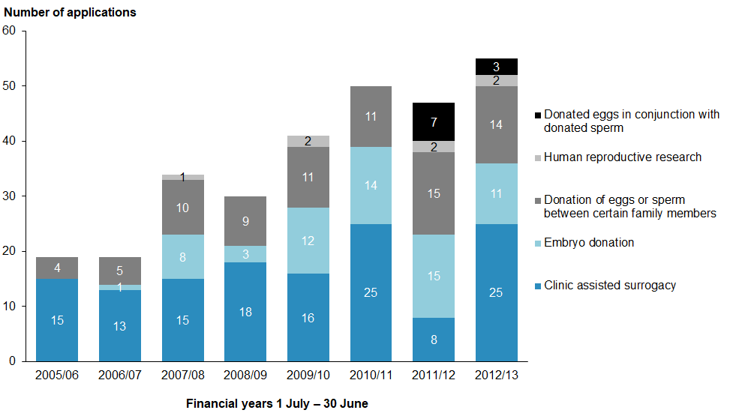

Of the 53 assisted reproductive procedure applications reviewed in 2012/13, a total of 42 were approved at first review, six were approved subject to conditions, and five were deferred.

ECART received two applications in 2012/13 for human reproductive research on non-viable gametes and embryos.

Creation and use, for reproductive purposes, of an embryo created from donated eggs in conjunction with donated sperm
In 2012/13, ECART reviewed three applications for the creation and use, for reproductive purposes, of an embryo created from donated eggs in conjunction with donated sperm. This is the second year in which ECART has reviewed this type of application.

As of 1 July 2013, all three applications were approved.

Applications for this category are current for three years from the date of approval. Of the 10 applications that have current ECART approval in this category, there were three live births in 2012/13.

Figure 2: Birth outcomes from current applications for creating and using, for reproductive purposes, an embryo created from donated eggs in conjunction with donated sperm by year, 2010/11–2012/13
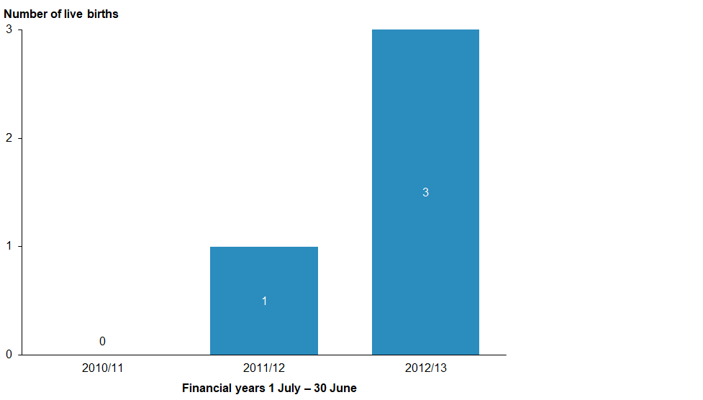
* Applications are current for three years; births resulting in the fourth year have not been captured in this figure.

Surrogacy arrangements involving providers of fertility services
In 2012/13, ECART reviewed 25 applications for surrogacy arrangements involving providers of fertility services.

As of 1 July 2013, 22 of the 25 surrogacy applications received by ECART in 2012/13 were approved, one application was approved subject to conditions, and two applications were deferred.

The number of clinic-assisted surrogacy applications received in 2012/13 rose by 147 percent compared with applications received in the last reporting year but was on par with reporting years before 2010/11.

Applications for this category are current for three years from the date of approval. Of the 59 applications that have current ECART approval in this category, there were four live births in 2012/13.

Surrogacy applications approved by ECART have so far resulted in 37 live births.

Figure 3: Birth outcomes of current applications for surrogacy arrangements involving providers of fertility services by year, 2005/06–2012/13
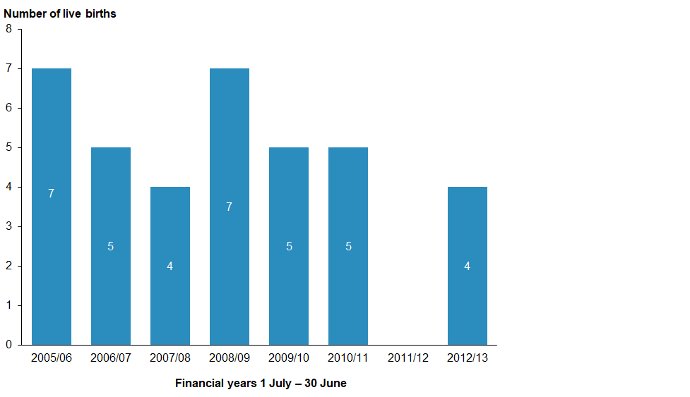
* Applications are current for three years; births resulting in the fourth year have not been captured in this figure.

Donation of eggs or sperm between certain family members
In 2012/13, ECART reviewed 14 applications for the donation of eggs or sperm between family members – similar to the number reviewed in 2010/11 (11).

As of 1 July 2013, 10 applications were approved, one was approved subject to conditions and the remaining three were deferred.

Applications for this category are current for three years from the date of approval. Of the 45 applications that have current ECART approval in this category, there were nine live births during 2012/13.

34 live births have so far resulted from the use of this assisted reproductive procedure following ECART approval.

Figure 4: Birth outcomes from current applications for the donation of eggs or sperm between certain family members by year, 2005/06–2012/13
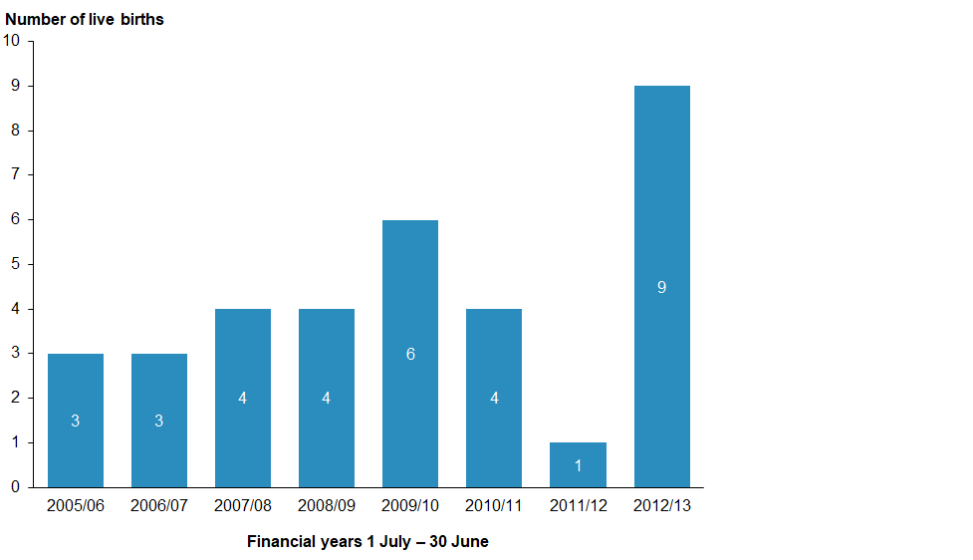
* Applications are current for three years; births resulting in the fourth year have not been captured in this figure.

Embryo donation for reproductive purposes
ECART reviewed 11 applications involving embryo donation for reproductive purposes in 2012/13, four fewer than in 2011/12.

As of 1 July 2013, all 11 applications were approved.

Applications for this category are current for three years from the date of approval. Of the 46 current applications in this category, there were six live births in 2012/13.

The use of this assisted reproductive procedure following ECART approval has resulted in a total of 24 live births so far.

Figure 5: Birth outcomes for current applications from embryo donation, by year,
2005/06–2012/13
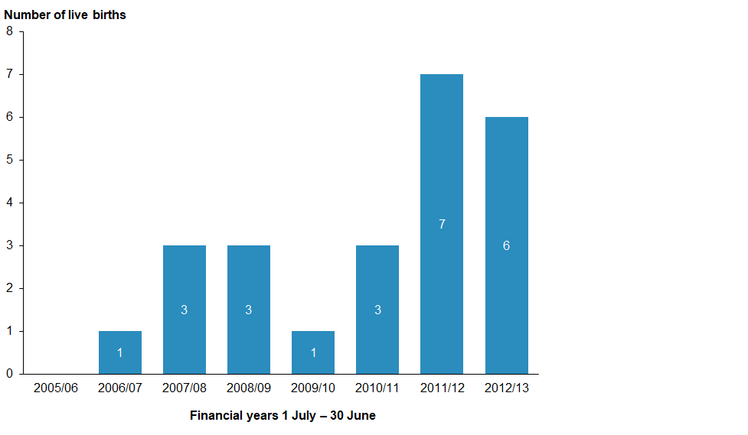
* Applications are current for three years; births resulting in the fourth year have not been captured in this figure.

Issues and complaints
This section outlines issues faced by the committee during 2012/13.

Advice on established procedures
In February 2011, the Minister of Health assigned ECART the function of giving ethical advice to fertility clinics on established procedures when requested by a fertility clinic to do so.

No such request was received in 2012/13.

Issues referred to ACART
No issues were referred to ACART in 2012/13.

Complaints received
ECART did not receive any complaints during 2012/13.

Appendix A: Applications reviewed by ECART in 2012/13
App # | Date of first review | Final review | Procedure | Initial decision | Final decision | Approval end date
E12/19 | 19/07/2012 | 28/08/2012 | Embryo created from donated eggs in conjunction with donated sperm | Approved STC | Approved | 28/08/2015
E12/20 | 19/07/2012 |  | Clinic-assisted surrogacy | Deferred | Withdrawn
E12/21 | 19/07/2012 |  | Donation of eggs or sperm between certain family members | Approved |  | 01/08/2015
E12/22 | 19/07/2012 |  | Clinic-assisted surrogacy | Approved |  | 01/08/2015
E12/23 | 19/07/2012 |  | Clinic-assisted surrogacy | Approved |  | 01/08/2015
E12/24 | 19/07/2012 |  | Donation of eggs or sperm between certain family members | Approved |  | 01/08/2015
E12/25 | 19/07/2012 |  | Embryo donation | Approved |  | 01/08/2015
E12/26 | 19/07/2012 |  | Donation of eggs or sperm between certain family members | Approved |  | 01/08/2015
E12/27 | 19/07/2012 |  | Clinic-assisted surrogacy | Approved |  | 01/08/2015
E09/21 | 19/07/2012 |  | Donation of eggs or sperm between certain family members | Approved |  | 01/08/2015
E12/28 | 27/09/2012 |  | Clinic-assisted surrogacy | Approved |  | 03/10/2015
E12/29 | 27/09/2012 |  | Clinic-assisted surrogacy | Approved |  | 03/10/2015
E12/30 | 27/09/2012 |  | Donation of eggs or sperm between certain family members | Approved |  | 03/10/2015
E12/31 | 27/09/2012 |  | Embryo created from donated eggs in conjunction with donated sperm | Approved |  | 03/10/2015
E12/32 | 27/09/2012 |  | Embryo donation | Approved |  | 03/10/2015
E12/33 | 27/09/2012 |  | Embryo created from donated eggs in conjunction with donated sperm | Approved |  | 03/10/2015
E12/34 | 27/09/2012 |  | Clinic-assisted surrogacy | Approved |  | 03/10/2015
E12/35 | 27/09/2012 |  | Embryo donation | Approved |  | 03/10/2015
E12/36 | 27/09/2012 |  | Embryo donation | Approved |  | 03/10/2015
E12/37 | 27/09/2012 |  | Donation of eggs or sperm between certain family members | Approved STC* | Approved | 27/09/2015
E12/38 | 27/09/2012 |  | Clinic-assisted surrogacy | Approved |  | 03/10/2015
E12/39 | 29/11/2012 |  | Embryo donation | Approved |  | 06/12/2015
E12/40 | 29/11/2012 |  | Clinic-assisted surrogacy | Approved |  | 06/12/2015
E12/41 | 29/11/2012 |  | Clinic-assisted surrogacy | Approved |  | 06/12/2015
E12/42 | 29/11/2012 |  | Clinic-assisted surrogacy | Approved |  | 06/12/2015
E12/43 | 29/11/2012 |  | Clinic-assisted surrogacy and egg donation | Approved |  | 06/12/2015
E12/44 | 29/11/2012 |  | Donation of eggs or sperm between certain family members | Approved |  | 06/12/2015
E12/45 | 29/11/2012 |  | Donation of eggs or sperm between certain family members | Approved |  | 06/12/2015
E12/46 | 29/11/2012 |  | Donation of eggs or sperm between certain family members | Deferred | Approved | 18/02/2016
E12/47 | 29/11/2012 |  | Embryo donation | Approved |  | 06/12/2015
E12/48 | 29/11/2012 | 10/01/2013 | Clinic-assisted surrogacy | Approved STC |  | 11/01/2016
E13/01 | 07/03/2013 |  | Clinic-assisted surrogacy | Approved |  | 08/03/2016
E13/02 | 07/03/2013 |  | Embryo donation | Approved |  | 08/03/2016
E13/03 | 07/03/2013 |  | Clinic-assisted surrogacy | Approved STC |  | 08/03/2016
E13/04 | 07/03/2013 |  | Clinic-assisted surrogacy | Approved |  | 08/03/2016
E13/05 | 07/03/2013 |  | Clinic-assisted surrogacy | Approved |  | 08/03/2016
E13/06 | 07/03/2013 |  | Embryo donation | Approved |  | 08/03/2016
E13/07 | 07/03/2013 |  | Clinic-assisted surrogacy | Approved |  | 08/03/2016
E13/08 | 07/03/2013 |  | Embryo donation | Approved |  | 08/03/2016
E13/09 | 07/03/2013 | 07/11/2013 | Clinic-assisted surrogacy | Deferred | Approved | 14/11/2016
E13/10 | 07/03/2013 | 07/05/2013 | Clinic-assisted surrogacy and egg donation | Approved STC | Approved | 08/05/2016
E09/27 | 07/03/2013 |  | Donation of eggs or sperm between certain family members | Approved STC | Approved | 11/04/2016
E10/09 | 07/03/2013 |  | Extension request clinic-assisted surrogacy | Approved STC | Approved | 02/04/2016
E13/11 | 30/05/2013 |  | Donation of eggs or sperm between certain family members | Approved |  | 04/06/2016
E13/12 | 30/05/2013 |  | Clinic-assisted surrogacy | Approved |  | 04/06/2016
E13/13 | 30/05/2013 |  | Clinic-assisted surrogacy | Approved |  | 04/06/2016
E13/14 | 30/05/2013 |  | Donation of eggs or sperm between certain family members | Approved |  | 04/06/2016
E13/15 | 30/05/2013 |  | Donation of eggs or sperm between certain family members | Approved |  | 04/06/2016
E13/16 | 30/05/2013 |  | Clinic-assisted surrogacy | Approved STC | Approved | 03/07/2016
E13/17 | 30/05/2013 |  | Embryo donation | Approved |  | 04/06/2016
E13/18 | 30/05/2013 |  | Embryo donation | Approved | Approved | 04/06/2016
E13/19 | 30/05/2013 |  | Donation of eggs or sperm between certain family members | Deferred | Application withdrawn
E13/20 | 30/05/2013 |  | Clinic-assisted surrogacy | Approved |  | 04/06/2016
E13/21 | 30/05/2013 |  | Clinic-assisted surrogacy | Approved |  | 30/05/2016
E13/22 | 30/05/2013 |  | Research | Deferred
E13/23 | 30/05/2013 |  | Research | Approved |  | 04/06/2016

Appendix B: Applications reviewed by ECART before 1 July 2012 but ongoing throughout 2012/13
App # | Date of first review | Final review | Procedure | Initial decision | Final decision | Approval end date
E09/18 | 11/08/2009 | 11/08/2009 | Donation of eggs or sperm between certain family members | Approved | Approved | 27/08/2012
E09/19 | 11/08/2009 | 11/08/2009 | Clinic-assisted surrogacy | Approved | Approved | 27/08/2012
E09/20 | 11/08/2009 | 11/08/2009 | Embryo donation | Approved | Approved | 27/08/2012
E09/21 | 11/08/2009 | 11/08/2009 | Donation of eggs or sperm between certain family members | Approved | Approved | 27/08/2012
E09/22 | 11/08/2009 | 11/08/2009 | Clinic-assisted surrogacy | Approved | Approved | 27/08/2012
E09/24 | 11/08/2009 | 11/08/2009 | Embryo donation | Approved | Approved | 27/08/2012
E09/26 | 13/10/2013 | 13/10/2013 | Embryo donation | Approved | Approved | 22/10/2012
E09/33 | 26/11/2009 | 26/11/2009 | Embryo donation | Approved | Approved | 10/12/2012
E09/34 | 26/11/2009 | 26/11/2009 | Embryo donation | Approved | Approved | 10/12/2012
E09/35 | 26/11/2009 | 26/11/2009 | Clinic-assisted surrogacy | Approved STC | Approved STC | 10/12/2012
E09/37 | 26/11/2009 | 18/02/2010 | Clinic-assisted surrogacy | Deferred | Approved | 10/12/2012
E10/01 | 18/02/2010 | 18/02/2010 | Donation of eggs or sperm between certain family members | Deferred | Approved | 03/03/2013
E10/02 | 18/02/2010 | 18/02/2010 | Embryo donation | Approved | Approved | 03/03/2013
E10/04 | 18/02/2010 | 18/02/2010 | Embryo donation | Approved | Approved | 03/03/2013
E10/08 | 18/02/2010 | 18/02/2010 | Donation of eggs or sperm between certain family members | Approved | Approved | 03/03/2013
E10/10 | 18/02/2010 | 17/05/2010 | Clinic-assisted surrogacy | Deferred | Approved | 17/05/2013
E10/11 | 18/02/2010 | 6/10/2010 | Donation of eggs or sperm between certain family members | Deferred | Approved | 06/10/2013
E10/13 | 22/04/2010 | 22/04/2010 | Clinic-assisted surrogacy | Approved | Approved | 04/05/2013
E10/14 | 22/04/2010 | 21/05/2010 | Embryo donation | Approved STC | Approved | 21/05/2013
E10/16 | 22/04/2010 | 03/03/2011 | Clinic-assisted surrogacy | Approved STC | Approved | 03/03/2014
E10/17 | 03/06/2010 | 03/06/2010 | Donation of eggs or sperm between certain family members | Approved | Approved | 17/06/2013
E10/20 | 03/06/2010 | 03/06/2010 | Clinic-assisted surrogacy | Approved | Approved | 17/06/2013
E10/22 | 29/07/2010 | 29/07/2010 | Clinic-assisted surrogacy | Approved | Approved | 12/08/2013
E10/23 | 29/07/2010 | 29/07/2010 | Clinic-assisted surrogacy | Approved STC | Approved | 28/10/2013
E10/24 | 29/07/2010 | 29/07/2010 | Clinic-assisted surrogacy | Approved | Approved | 12/08/2013
E10/25 | 29/07/2010 | 08/02/2011 | Donation of eggs or sperm between certain family members | Deferred | Approved | 08/02/2014
E10/26 | 29/07/2010 | 29/07/2010 | Embryo donation | Approved | Approved | 12/08/2013
E10/28 | 29/07/2010 | 29/07/2010 | Donation of eggs or sperm between certain family members | Approved | Approved | 12/08/2013
E10/29 | 29/07/2010 | 25/11/2010 | Clinic-assisted surrogacy | Deferred | Approved | 09/12/2013
E10/31 | 29/07/2010 | 16/09/2010 | Donation of eggs or sperm between certain family members | Approved STC | Approved | 22/09/2013
E10/32 | 29/07/2010 | 17/12/2010 | Clinic-assisted surrogacy | Deferred | Deferred | N/A
E10/33 | 29/07/2010 | 29/07/2010 | Clinic-assisted surrogacy | Approved | Approved | 12/08/2013
E10/35 | 16/09/2010 | 16/09/2010 | Clinic-assisted surrogacy | Approved | Approved | 22/09/2013
E10/38 | 16/09/2010 | 16/09/2010 | Embryo donation | Approved | Approved | 22/09/2013
E10/39 | 16/09/2010 | 17/02/2011 | Clinic-assisted surrogacy | Approved | Approved | 22/09/2013
E10/41 | 25/11/2010 | 25/11/2010 | Donation of eggs or sperm between certain family members | Approved | Approved | 09/12/2013
E10/42 | 25/11/2010 | 15/12/2010 | Clinic-assisted surrogacy | Deferred | Approved STC | 15/12/2013
E10/43 | 25/11/2010 | 25/11/2010 | Clinic-assisted surrogacy | Approved | Approved | 09/12/2013
E10/44 | 25/11/2010 | 25/11/2010 | Clinic-assisted surrogacy | Approved | Approved | 09/12/2013
E10/45 | 25/11/2010 | 25/11/2010 | Clinic-assisted surrogacy | Approved | Approved | 09/12/2013
E10/46 | 25/11/2010 | 25/11/2010 | Clinic-assisted surrogacy | Approved | Approved | 09/12/2013
E10/47 | 25/11/2010 | 25/11/2010 | Donation of eggs or sperm between certain family members | Approved | Approved | 09/12/2013
E10/49 | 25/11/2010 | 25/11/2010 | Clinic-assisted surrogacy | Approved | Approved | 09/12/2013
E11/01 | 17/02/2011 | 17/02/2011 | Donation of eggs or sperm between certain family members | Approved | Approved | 03/03/2014
E11/02 | 17/02/2011 | 17/02/2011 | Clinic-assisted surrogacy | Approved | Approved | 03/03/2014
E11/03 | 17/02/2011 | 17/02/2011 | Embryo donation | Deferred | Deferred | N/A
E11/04 | 17/02/2011 | 17/02/2011 | Donation of eggs or sperm between certain family members | Approved | Approved | 03/03/2014
E11/05 | 17/02/2011 | 17/02/2011 | Donation of eggs or sperm between certain family members | Approved | Approved | 03/03/2014
E11/06 | 17/02/2011 | 17/02/2011 | Embryo donation | Approved | Approved | 03/03/2014
E11/07 | 17/02/2011 | 17/02/2011 | Clinic-assisted surrogacy | Approved | Approved | 03/03/2014
E11/08 | 17/02/2011 | 24/03/2011 | Embryo donation | Approved STC | Approved | 24/03/2014
E11/09 | 17/02/2011 | 16/03/2011 | Embryo donation | Deferred | Approved | 16/03/2014
E11/11 | 17/02/2011 | 17/02/2011 | Clinic-assisted surrogacy | Approved | Approved | 03/03/2014
E11/12 | 17/02/2011 | 17/02/2011 | Clinic-assisted surrogacy | Approved | Approved | 03/03/2014
E11/13 | 12/05/2011 | 12/05/2011 | Embryo donation | Approved | Approved | 26/05/2014
E11/14 | 12/05/2011 | 13/05/2011 | Embryo donation | Approved STC | Approved | 23/6/2014
E11/15 | 12/05/2011 | 12/05/2011 | Clinic-assisted surrogacy | Approved | Approved | 26/05/2014
E11/16 | 12/05/2011 | 12/05/2011 | Embryo donation | Approved | Approved | 26/05/2014
E11/17 | 12/05/2011 | 12/05/2011 | Donation of eggs or sperm between certain family members | Approved | Approved | 26/05/2014
E11/18 | 12/05/2011 | 12/05/2011 | Donation of eggs or sperm between certain family members | Approved | Approved | 26/05/2014
E11/19 | 12/05/2011 | 12/05/2011 | Embryo donation | Approved | Approved | 26/05/2014
E11/20 | 12/05/2011 | 13/05/2011 | Embryo donation | Deferred | Approved | 17/06/2014
E11/22 | 12/05/2011 | 12/05/2011 | Embryo donation | Approved | Approved | 26/05/2014
E11/23 | 21/07/2011 | 21/07/2011 | Donation of eggs or sperm between certain family members | Approved | Approved | 04/08/2014
E11/24 | 21/07/2011 | 21/07/2011 | Embryo donation | App with recs | App with recs | 04/08/2014
E11/25 | 21/07/2011 | 21/07/2011 | Embryo created from donated eggs in conjunction with donated sperm | Approved STC | Approved | 11/10/2014
E11/26 | 21/07/2011 | 21/07/2011 | Embryo donation | Deferred | Approved | 11/10/2014
E11/27 | 21/07/2011 | 29/09/2011 | Donation of eggs or sperm between certain family members | Approved STC | Approved | 1410/2014
E11/28 | 21/07/2011 | 21/07/2011 | Donation of eggs or sperm between certain family members | Approved | Approved | 04/08/2014
E11/29 | 21/07/2011 | 21/07/2011 | Clinic-assisted surrogacy | Approved | Approved | 04/08/2014
E11/30 | 21/07/2011 | 21/07/2011 | Embryo donation | Approved | Approved | 04/08/2014
E11/31 | 21/07/2011 | 21/07/2011 | Embryo donation | Approved | Approved | 04/08/2014
E11/32 | 29/09/2011 | 29/09/2011 | Embryo donation | Approved | Approved | 11/10/2014
E11/33 | 29/09/2011 | 05/10/2011 | Embryo donation | Approved STC | Approved | 14/10/2014
E11/34 | 29/09/2011 | 29/09/2011 | Embryo donation | Approved | Approved | 14/10/2014
E11/35 | 29/09/2011 | 29/09/2011 | Clinic-assisted surrogacy | App with recs | App with recs | 14/10/2014
E11/36 | 29/09/2011 | 29/09/2011 | Embryo created from donated eggs in conjunction with donated sperm | Approved | Approved | 14/10/2014
E11/37 | 29/09/2011 | 29/09/2011 | Embryo donation | Approved | Approved | 14/10/2014
E11/38 | 29/09/2011 | 29/09/2011 | Embryo donation | Approved | Approved | 14/10/2014
E11/39 | 29/09/2011 | 29/09/2011 | Embryo created from donated eggs in conjunction with donated sperm | Approved | Approved | 29/09/2014
E11/40 | 29/09/2011 | 29/09/2011 | Embryo donation | Approved | Approved | 29/09/2014
E11/41 | 29/09/2011 | 13/10/2001 | Donation of eggs or sperm between certain family members | Deferred | Approved | 14/10/2014
E11/42 | 24/11/2011 | 20/01/2012 | Research | Approved STC | Approved | 20/01/2015
E11/43 | 24/11/2011 | 24/11/2011 | Donation of eggs or sperm between certain family members | Approved | Approved | 01/12/2014
E11/44 | 24/11/2011 | 24/11/2011 | Embryo created from donated eggs in conjunction with donated sperm | Approved | Approved | 01/12/2014
E11/45 | 24/11/2011 | 24/11/2011 | Donation of eggs or sperm between certain family members | Approved | Approved | 01/12/2014
E11/46 | 24/11/2011 | 24/11/2011 | Embryo created from donated eggs in conjunction with donated sperm | Approved | Approved | 01/12/2014
E11/47 | 24/11/2011 | 24/11/2011 | Donation of eggs or sperm between certain family members | Approved | Approved | 01/12/2014
E11/48 | 24/11/2011 | 24/11/2011 | Clinic-assisted surrogacy | Approved | Approved | 01/12/2014
E11/49 | 24/11/2011 | 24/11/2011 | Embryo donation | Approved | Approved | 01/12/2014
E10/42 | 25/11/2010 | 05/03/2012 | Clinic-assisted surrogacy | Approved | Approved | 05/03/2015
E12/01 | 23/02/2012 | 23/02/2012 | Donation of eggs or sperm between certain family members | Approved | Approved | 05/03/2015
E12/02 | 23/02/2012 | 23/02/2012 | Embryo donation | Approved | Approved | 05/03/2015
E12/03 | 23/02/2012 | 21/03/2012 | Donation of eggs or sperm between certain family members | Approved STC | Approved | 21/032015
E12/04 | 23/02/2012 | 23/02/2012 | Donation of eggs or sperm between certain family members | Approved | Approved | 05/03/2015
E12/05 | 23/02/2012 | 16/04/2012 | Embryo created from donated eggs in conjunction with donated sperm | Approved STC | Approved | 16/04/2015
E12/06 | 23/02/2012 | 23/02/2012 | Embryo created from donated eggs in conjunction with donated sperm | Approved | Approved | 05/03/2015
E12/07 | 23/02/2012 | 23/02/2012 | Embryo donation | Approved | Approved | 05/03/2015
E12/08 | 23/02/2012 | 23/02/2012 | Donation of eggs or sperm between certain family members | Approved | Approved | 05/03/2015
E12/09 | 10/05/2012 | 19/07/2012 | Donation of eggs or sperm between certain family members | Approved STC | Approved | N/A
E12/10 | 10/05/2012 | 10/05/2012 | Embryo donation | Approved | Approved | 15/05/2015
E12/11 | 10/05/2012 | 10/05/2012 | Donation of eggs or sperm between certain family members | Approved | Approved | 15/05/2015
E12/12 | 10/05/2012 | 11/06/2012 | Embryo donation | Approved STC | Approved | 11/06/2015
E12/13 | 10/05/2012 |  | Donation of eggs or sperm between certain family members | Approved STC | Declined | N/A
E12/14 | 10/05/2012 | 10/05/2012 | Donation of eggs or sperm between certain family members | Approved | Approved | 15/05/2015
E12/15 | 10/05/2012 | 10/05/2012 | Clinic-assisted surrogacy | Approved | Approved | 15/05/2015
E12/16 | 10/05/2012 | 10/05/2012 | Clinic-assisted surrogacy | Approved | Approved | 15/05/2015
E12/17 | 10/05/2012 | 17/06/2012 | Research | Approved STC | Approved | 17/06/2015
E12/18 | 10/05/2012 | 10/05/2012 | Clinic-assisted surrogacy | Approved | Approved | 15/05/2015

Remains deferred for further information about the wellbeing of the birth mother and any resulting child under principles (a) and (c) of the HART Act.
Remains deferred for further information about the wellbeing of the recipient woman and any resulting child under principles (a) and (c) of the HART Act.

